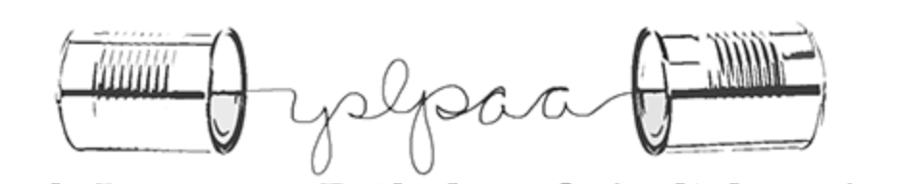
Yukon Speech-Language Pathology & Audiology Association (YSLPAA)
Private Practice Registry Summer 2022
Practitioner Name | Areas of Practice
Karen Rach  867-334-6321  karenrachslp@gmail.com | Preschool children (0-5 years)  School-aged children
Anne-Soizic Raux  annesoizic.raux@gmail.com  www.asrauxorthophonie.com | Preschool children (0-5 years)  School-aged children  Adults  French - English
Yoel Droguett  info@voicelife.ca  www.voicelife.ca | Voice Disorders  Vocal Technique
Laura Hutchinson  519-546-1974  www.paths2communication.com  www.paths2communication.com | Preschool children (0-5 years)  School-aged children
Boreal Clinic  867-332-6405  www.borealclinic.com  Evie Allen  evie@borealclinic.com  Kelsey Kerr  kelsey@borealclinic.com  Helena Burrows  helena@borealclinic.com  Kyle Smith  kyle@borealclinic.com | Preschool children (0-5 years)  School-aged children  Adults  Hearing Aids  Audiology

